Directions (Questions 1-3): Two statements are given in each of the following questions, followed by two conclusions numbered I and II. You have to take the given two [statements](https://www.toppr.com/guides/reasoning-ability/statements/) to be true even if they seem to be at variance from commonly known facts. Read the conclusions and then decide which of the given conclusions logically follows from the two disregarding known facts.

Give answer:

a: if only conclusion I follows

b: if only conclusion II follows

c: if either conclusion I or II follows

d: if neither I nor II follows

e: if both conclusions I and II follow

Q1: Statements:

Some notebooks are books.

All books are papers.

Conclusions

I. Some notebooks are papers.

II. No paper is a notebook.

Q2: Statements:

All huts are mansions.

All mansions are temples.

Conclusions:

I. Some temples are huts.

II. Some temples are mansions.

Q3: Statements:

All pens are pencils.

No pencil is a cap.

Conclusions:

I. All caps are pencils.

II. Some caps are pencils.

Find Your Answers Here

Q1: (c), Q2: (e), Q3: (d)

Q4: Statements:

All flowers are candles.

All lanterns are candles.

Conclusions:

Some flowers are lanterns.

Some candles are lanterns.

Solution:

Three possible diagrams are shown above for the given statements.  
Conclusion I follows from last two possible solutions, but does not follow from the first possible solution. Therefore, this conclusion is false.  
Conclusion II follows from all the three possible solutions.  
Therefore, conclusion II is true.

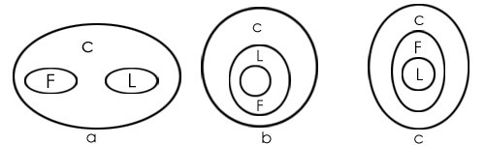

Which of the two conclusions can be concluded on the basis of given statements?

Statements:

Some parrots are scissors.

Some scissors are not combs.

Conclusions:

Some scissors are parrots.

Some combs are parrots.

Solution: Now, in this case, the possible conclusion is: Some scissors are parrots (I to I), as the universal principal no. 4 says, that with two particular statements only I to I is possible. Therefore, only 1 conclusion is possible. Nothing else is possible.

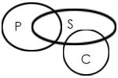

Example 3: Which of the two conclusions can be concluded on the basis of given statements?

Statements:

All prisoners are men.

No man is educated.

Conclusions:

All prisoners are uneducated.

Some men are prisoners.

Solution: Two possible diagrams are shown below for the given statements.

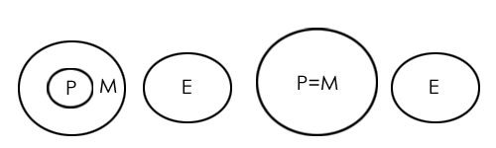

Conclusion I follows from both the possibilities, so conclusion I is true.  
Conclusion II also follows from both the possibilities, so conclusion II is also true.   
Therefore, both conclusions are true.

xample 4: Which of the two conclusions can be concluded on the basis of given statements?

Statements:

All sides are lengths.

No length is a breadth.

Conclusions:

All lengths are sides

No breadth is a side

Solution: Two possible diagrams are shown below for the given statements.

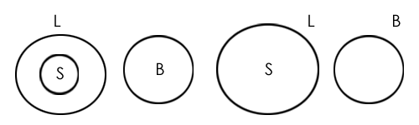

Conclusion I: False (conclusion follows from the second possibility but doesn't follow from the first possibility)  
Conclusion II: True (conclusion follows from both the Venn diagram possibilities.)

Therefore, only conclusion II is true.