Microprocessor:-

A microprocessor is a controlling unit of a micro-computer, fabricated on a small chip capable of performing Arithmetic Logical Unit (ALU) operations and communicating with the other devices connected to it. In this tutorial, we will discuss the architecture, pin diagram and other key concepts of microprocessors.
A microprocessor can be classified into three categories
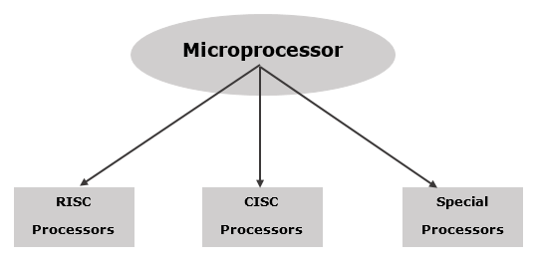

8253/54 :-
- Pin diagram for 8253:-
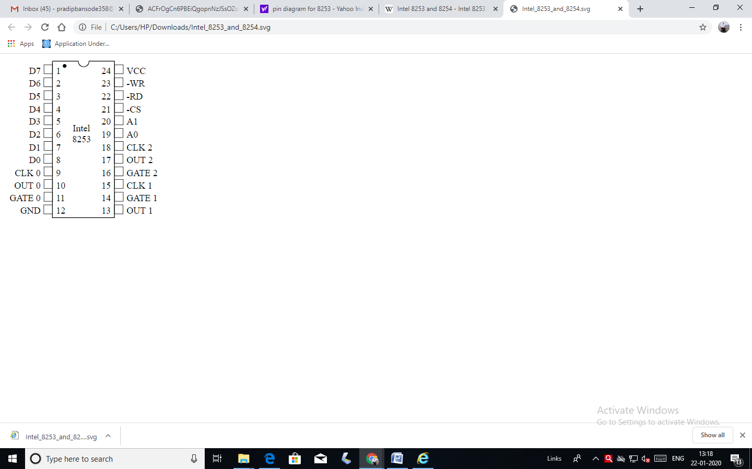

Mode 0 ─ Interrupt on Terminal Count

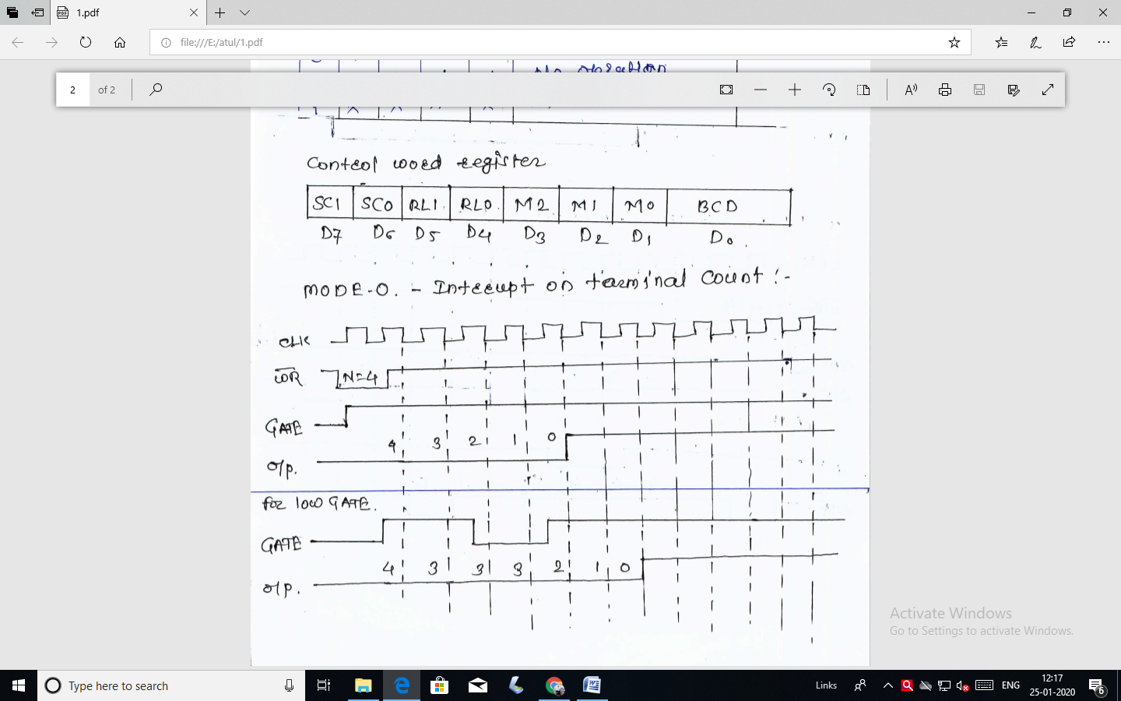
- It is used to generate an interrupt to the microprocessor after a certain interval.
- Initially the output is low after the mode is set. The output remains LOW after the count value is loaded into the counter.
- The process of decrementing the counter continues till the terminal count is reached, i.e., the count become zero and the output goes HIGH and will remain high until it reloads a new count.
- The GATE signal is high for normal counting. When GATE goes low, counting is terminated and the current count is latched till the GATE goes high again.

Mode 1 – Programmable One Shot

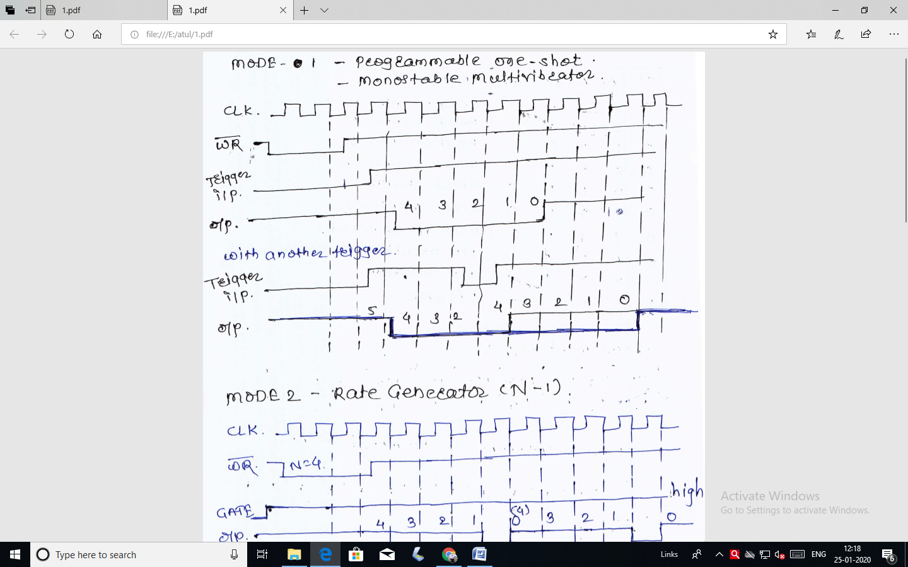
- It can be used as a mono stable multi-vibrator.
- The gate input is used as a trigger input in this mode.
- Low to high signals is applied to Gate which acts as trigger signal.
- In this OUT becomes initially high after the mode is set count start
- After Mode set operation counter is loaded by a count value N. The counter decrements count and o/p (OUT) goes low for N clock cycles.
- WR pin initially low when it becomes high then the count start otherwise count does not start. Counting is only does on falling edge.
- Trigger i/p initially low whenever it becomes high it shows trigger. So it ordered counter start counting in decrement
- Output initially high whenever the count start it becomes low then and then counting start.

Mode 2 – Rate Generator
- In mode 2 counter acts as a simple divide by N counter.
- When mode set o/p becomes initially high. After mode set counter loaded by a count N.
- For Mode 2 operation GATE is kept high.
- o/p remains high for (N-1) clock pulse and then goes low for one clock pulse as shown below.
- After o/p becomes high again and the count N is automatically reloaded into counter.
- Again the o/p remains high for (N-1) clock pulses and goes low for one clock pulse
- This process is repeated as long as the GATE i/p is made low the counter is divided and o/p stays high.

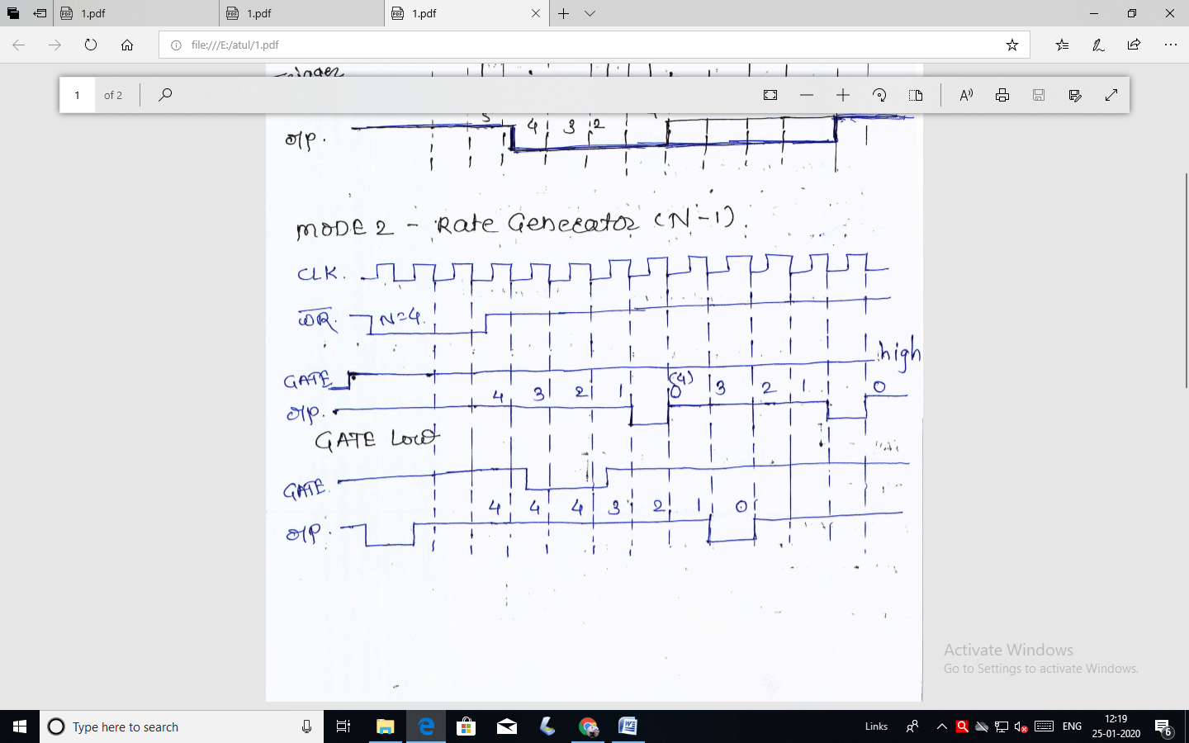

Mode 3 – Square Wave Generator
- In this Mode-3 the counter acts as a square wave generator.
- After Mode set operation the counter is loaded by a count value N
- For Mode 3 GATE is kept High
- For even values of N the o/p remains high for N/2 clock pluses.
- On terminal count the o/p state is changed and counter is automatically reloaded with the fall count and the whole process is repeated.
- Thus continued square wave is obtained.
- For odd values of N the o/p remains high for N+1/2 clock pulse and low for N-1/2 clock pulses.

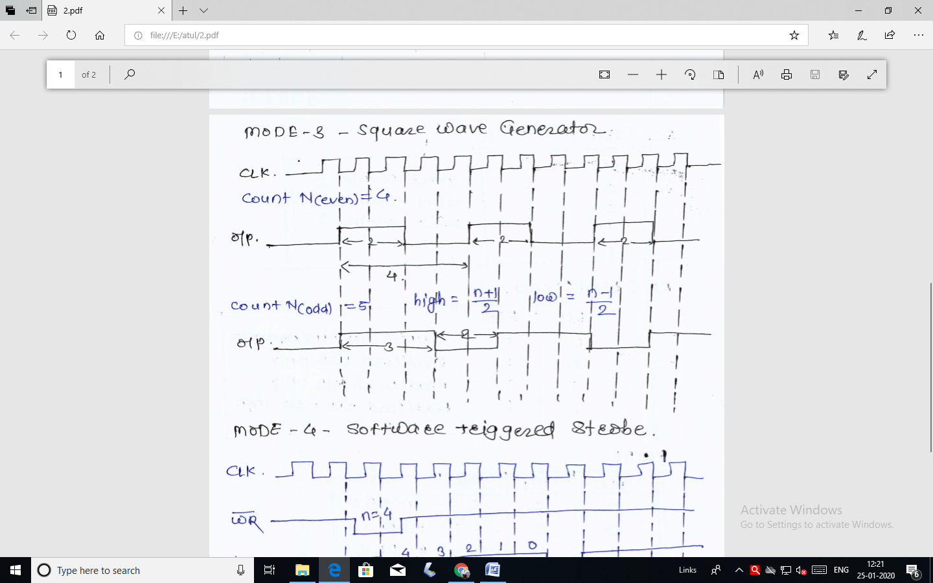

Mode 4 − Software Triggered Mode

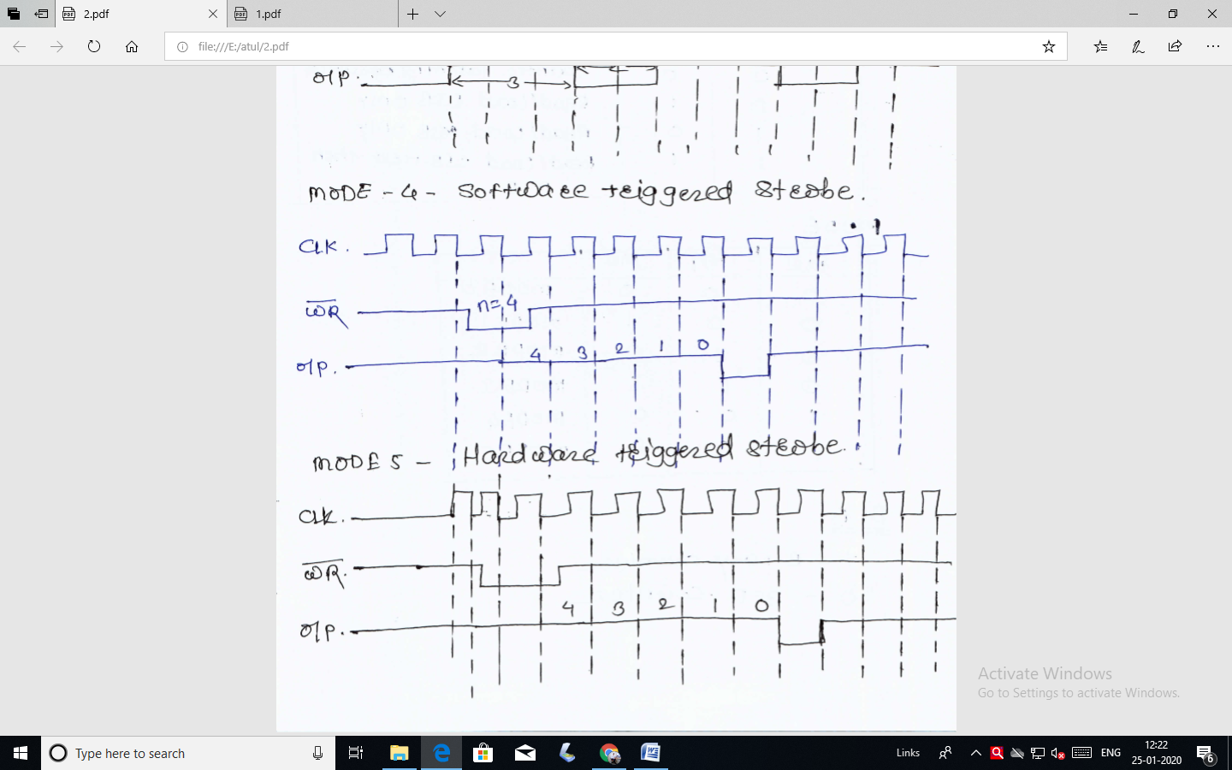
- In this Mode 4 operation the o/p of counter becomes initially high after the mode is set.
- The counter begins counting after the count is loaded in count register
- On the terminal count, the output goes low for one clock cycle then goes HIGH. This low pulse can be used as a strobe.

Mode 5 – Hardware Triggered Mode
- This mode generates a strobe in response to an externally generated signal.
- This mode is similar to mode 4 except that the counting is initiated by a signal at the gate input, which means it is hardware triggered instead of software triggered.
- After it is initialized, the output goes high.
- When the terminal count is reached, the output goes low for one clock cycle.
BLOCK DIAGRAM OF 8253:-
Block diagram: a diagram of a system in which the principal parts or functions are represented by blocks connected by lines that show the relationships of the blocks.
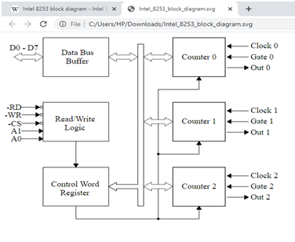
This is 8253 the programmable interval timers (PIT’s) designed for microprocessor to perform timing and counting functions using 3 – 16 bit counters.
- Data Bus Buffer:-
- This Buffer is within 8253
- It is a 3 state, Bidirectional Buffer
- It is used to interface 8253 to CPU
It has 3 Basic functions
1. Programming the modes of 8253.
2. Loading the count resistors.
3 Reading the count values.
- Read/Write Logic
- It consists of five signals RD, WR, CS, A0 and A1
- RD and WR signals are connected to IOR and low.
- Address lines A0, A1 of cpu are connected to lines A0 and A1 of 8253 and CS is tied to a decoded address.
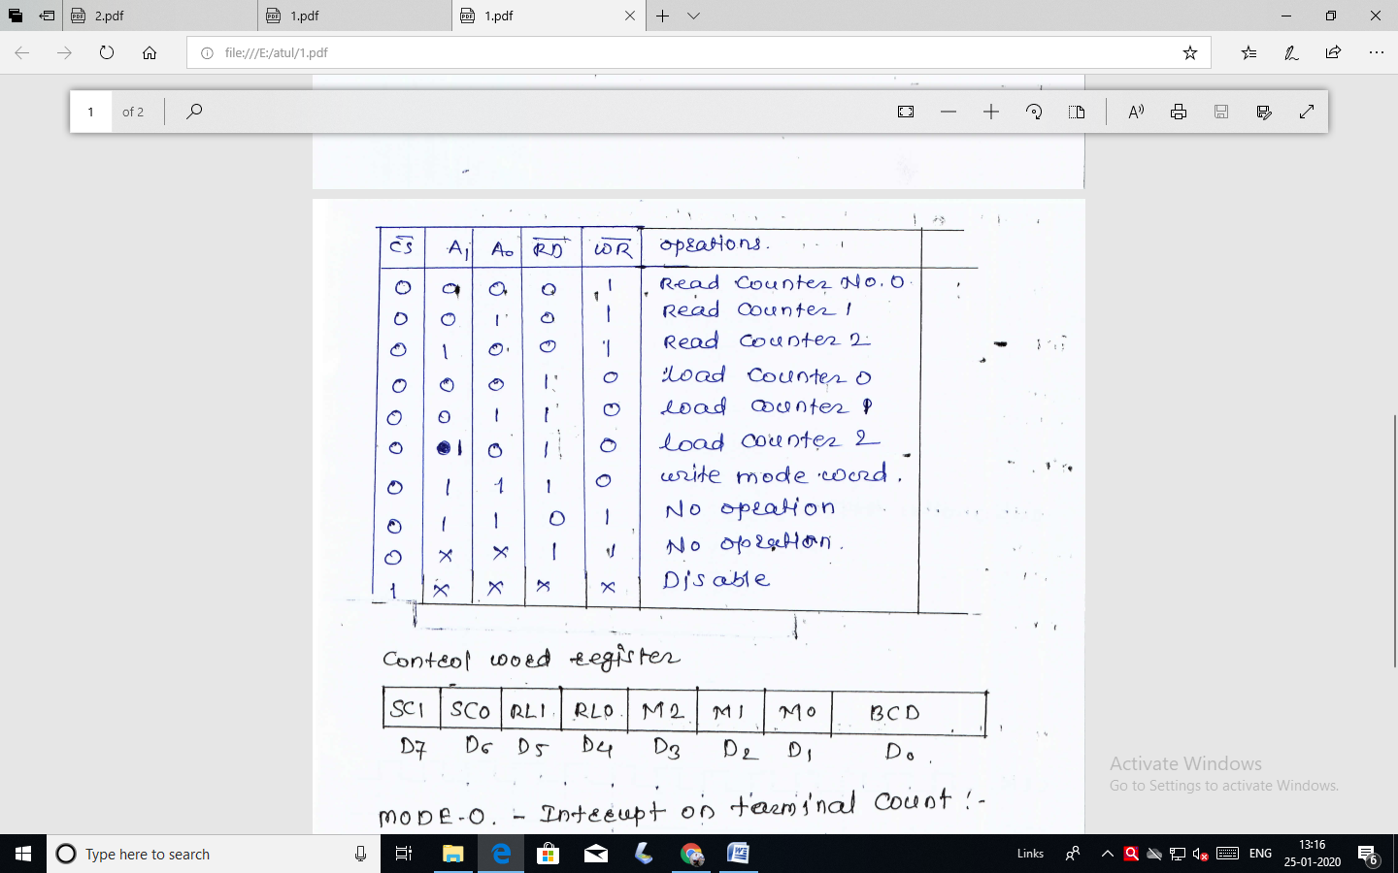
- Control Word Register :-
- When A0 and A1 both are high
e.i. 11 the control word register is selected.
This bits D7 and D6 are selected one of the counter
D5 and D4 are for loading/reading the count.
D3, D2 and D1 are for selection of operating mode selection. (six Modes)
D0 is for selection of Binary or BCD counting

  - SC ( select counter) :- To select counter SC0 and SC1 are set as follows:
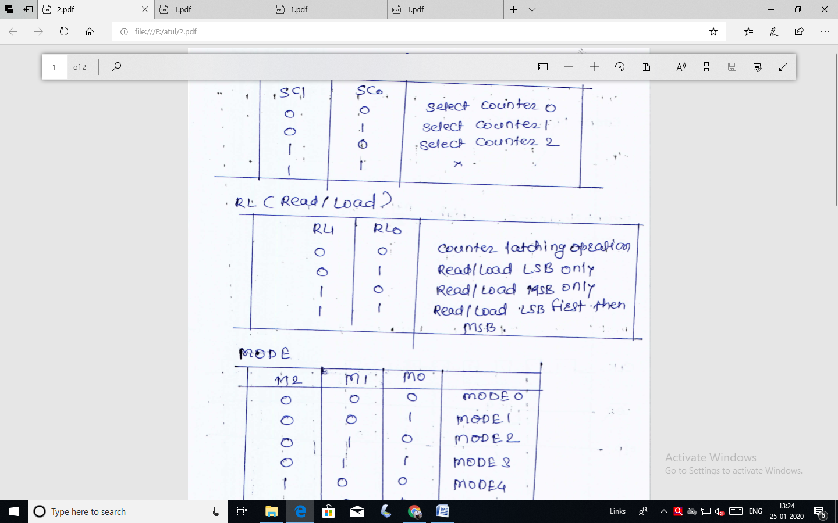
  - RL (Read/ Load)
To read/Load counts RL0 and RL1 are set as follow
  - Mode selection:
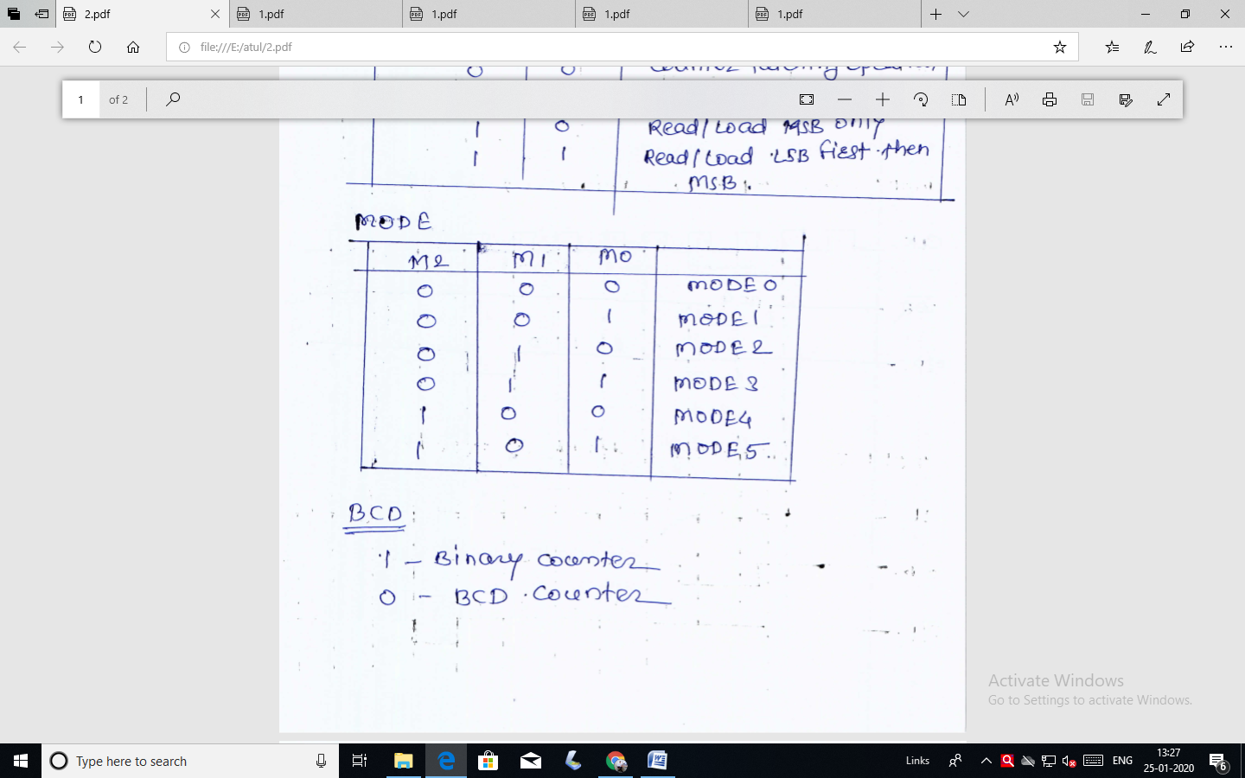
  - Selection of type of counting :-
- Counters :-
- Each counters has 2 i/p pins i.e. CLOCK and GATE and one pin for OUT O/P
- To operate a counter a 16 bit count is loaded in its register. On command it begins to decrement the count until it reaches 0, then it generates a pulse that can be used to interrupt the CPU.
8255 :-
Pin Diagram :-
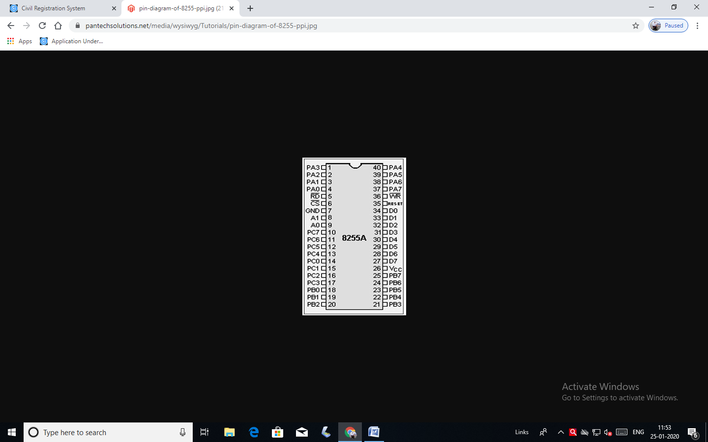
Block Diagram :-
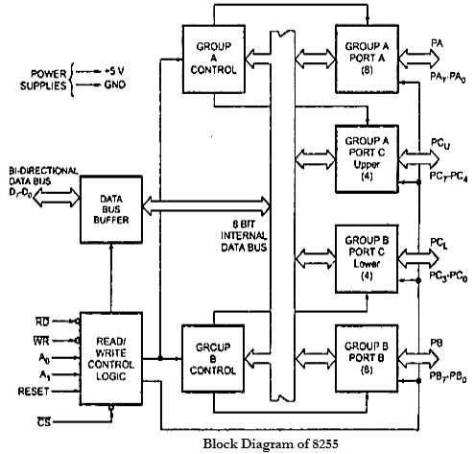

Operating modes :-

Here we come with a new topic operational modes of 8255 PPI IC. In my previous post I discussed on details of “Programmable Peripheral Interface (PPI) IC 8255”. Now here we see how we can classified 8255 PPI IC depending upon its operational modes. The operational modes of 8255 PPI IC can be classified into two broad groups.
- I/O Mode
- BIT Set Reset (BSR) modes.
Further I/O mode be subdivided into three groups.
- Mode 0
- Mode 1
- Mode 2.
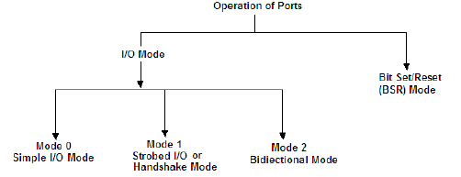
Now we go for some elaborate discussion on all the operational modes of 8255 PPI IC.

I/O Mode
I/O mode refer as input/output mode. So for any input/output operation of microprocessor this mode will activated. As we know the input/output mode can further be subdivided into three groups:
Mode 0 – Simple Input/output mode
In this mode the 8 bit port A (PA0-PA7) of 8255 IC can be configured as input or output port. In the similar fashion port B (PB0-PB7) can also be configured as input or output operation. However there is flexibility for the port C. It can be divided into two 4 bit ports, the port C_{Lower} (PC0-PC3) and port C_{Upper} (PC4-PC7). Each of them can be set independently for input or output operation. In this way can say there are four ports (port-A, port-B, port C_{Lower} and port C_{Upper}) and each of them can be set either as an input port or an output port.
Here these ports are simple input or output ports. That means these ports can work without handshaking. In this mode the outputs are latched whereas the inputs are not latched.
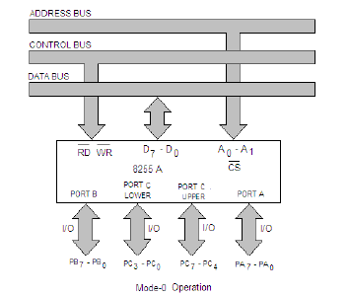
Mode 1 – Strobed Input/output or Handshake mode
Mode 1 is a second mode of 8255 I/O mode. In this mode of operation handshaking is used for the input or output data transfer. Another important think we have to remember that there are two groups in 8255 PPI, Group A and Group B. Both these groups have one 8-bit port and one 4-bit port.Group A consist Port-A and Port C_{Upper}. And group B consist Port-B and Port C_{Lower}. The 8-bit port of each group can be programmed for input or output operation with latched input and latched output facilities. The bits of Port C are used for handshaking.
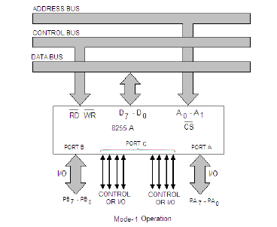
Mode 2 – Bidirectional Mode
So the final mode of 8255 is Mode 2. In this mode Port A can be programmed to operate as a bidirectional port. When Port A is programmed in this mode of operation, Port B can be used either in Mode 0 or Mode 1. For mode 2 operation PC3 to PC7 bits are used for handshaking. In this mode too both inputs and outputs are latched.
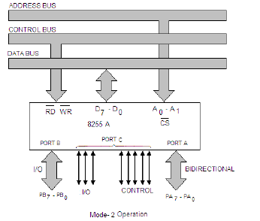

Bit Set/Reset Mode
In BSR mode, any of the 8-bits of port C can be Set or reset using a single control word written into the control register. Because of this facility it helps the programmer to control the port C pin output individually. It is also used in mode 1 and mode 2 operation. In bellow you will find the control word format for BSR mode.

Hope this discussion on operational modes of 8255 PPI IC will cleared your concept regarding that.

- Pin diagram of 8259:-
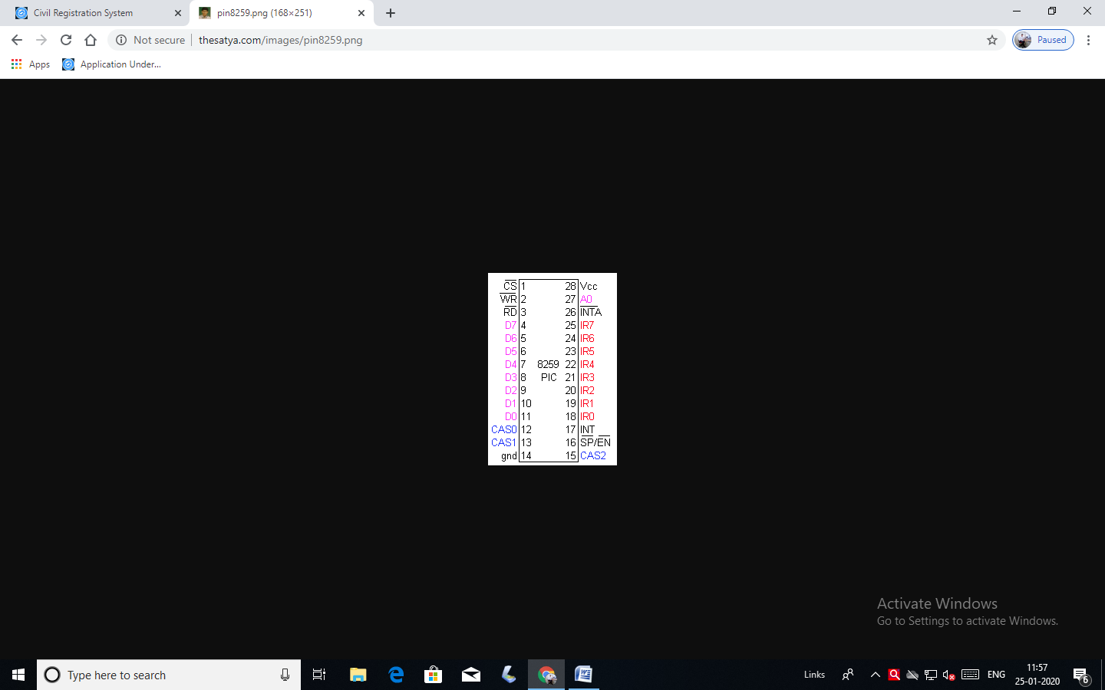
- Cs :- chip select pin (active low)
- RD :- Read the data on IC and send it for CPU
- WR :- write the data on CPU to IC.
- D0-D7 :- Bidirectional Data bus
Control, status, intrrupt to CPU is transforming via this bus.
- CAS0- CAS2 :- Cascade lines
To cascade the another 8259 ic’s (max 7)
- SP/EN :- slave program/enable Buffer
It is related to cascade control
- INT :- Valid intrrupt from peripheral device
It is used to intrrupt from a CPU
- INTA :- It is used as intrrupt acknowledge.
- IR0-IR7 :- Intrrupt Requests
I/O devices send interrupt request through these lines.
- A0 – Address lines
It is inconjuction with RD, WR, and CS
Using intrrupt CPU writes and status the CPU wants to read.

- Block Diagram of 8259 Microprocessor
- 8259 microprocessor can be programmed according to given interrupts condition and it can be provided either with level or edge triggered interrupt level.
- It can be programmed either work in 8085 or in 8086 microprocessors.
- Individual interrupt bits can be masked.
- By conducting more number of 8259 we can get upto 64 interrupt pins.

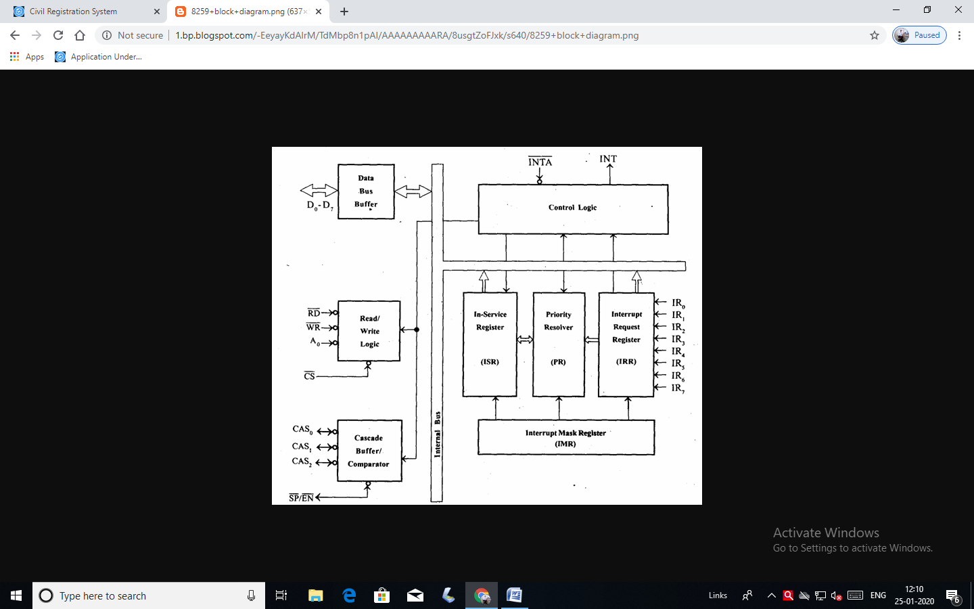
It contains 3 rigisters commonly known as ISR, IRR, IMR & there is 1 priority resolver (PR).
Interrupt Request Register (IRR):
It stores those bits which are requesting for their interrupt services.

Interrupt Service Register (ISR):
It stores that interrupt levels which is currently being served.

Interrupt Mask Register (IMR):
It stores that interrupt levels which have to be masked. These interrupts levels are already accepted by 8259 microprocessor.

Priority Resolver (PR):
It examines all the 3 registers and set the priority of interrupts and set the interrupt levels in ISR which has highest priority and rest the interrupt bit is IRR which is already accepted.
SP/EN (low active pin):
If its value is 1 it works in master mode & if its value=e is 0 then it works in slave mode.

Cascade Buffer:
It is used to cascade more number of Programmable Interrupt Controller to increase the interrupts handling capability upto 64 level.
This block stores and compares the ID’s of all 8259 used in the system. The 3 I/O pins CAS0-CAS2 are O/p when 8259 is used as master.CAS0-CAS2 I/p when 8259 acts as slave mode. The 8259 is master mode sends. The ID of interpting slave device in these lines. Slave thus selected will send it preprogrammed vector add on the data bus during the next.

8259 Operating Modes
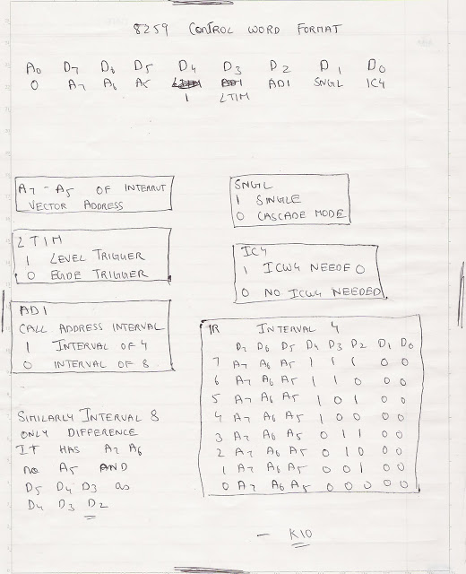
MODES OF 8259
1) FULLY NESTED MODE
This is a general purpose mode where all IR's are arranged in highs to lowest.
IR0 highest and IR7 lowest.
2) AUTOMATIC ROTATION MODE
In this mode a device after being serviced receives the lowest priority.
3) SPECIFIC ROTATION MODE
In this user can select any IR for lowest priority thus fixing all priorities.

Pin Diagram of 8257:
Fig. 14.61 shows Pin Diagram of 8257.
Data Bus (D₀-D₇) : These are bi-directional tri-state signals connected to the system data bus. When CPU is having control of system bus it can access contents of address register, status register, mode set register, and a terminal count register and it can also program, control registers of DMA controller, through the data bus.
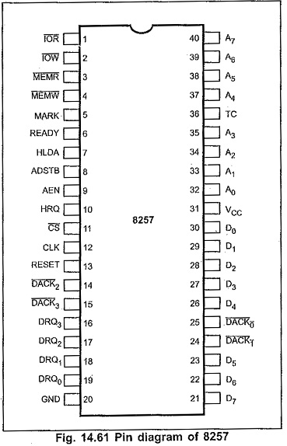
During DMA cycles these lines are used to send the most significant bytes of the memory address from one of the
Address Bus (A₀-A₃ and A₄-A₇) : The four least significant lines A₀-A₃ are bi – directional tri – state signals. In the slave mode they are inputs and used by the CPU to address the register to be loaded or read. In the master mode they output the lower 4 bits of the address for DMA operation. A₄-A₇ are unidirectional lines, provide 4-bits of address during DMA service.
Address Strobe (ADSTB) : This signal is used to demultiplex higher byte address and data using external latch.
Address Enable (AEN) : This active high signal enables the 8-bit latch containing the upper 8-address bits onto the system address bus. AEN can also be used to disable other system bus and data bus drivers during DMA transfers.
Memory Read and Memory Write ( MEMR, MEMW) : These are active low tri-state signals. The MEMR signal used to access data from the addressed memory location during a DMA read or memory-to-memory transfer and MEMW signal is used to write data to the addressed memory location during DMA write or memory to memory transfer.
I/O Read and I/O Write ( IOR and IOW ) : These are active low bi-directional signals. In idle cycle, these are an input control signals used by CPU to read/write the control registers. In the active cycle IOR signal is used to access data from a peripheral and IOW signal is used to send data to the peripheral.
Chip Select (CS) : This is an active low input, used to select the 8257 as an I/O device during the slave mode. This allows CPU to communicate with Pin Diagram of 8257.in master mode autoimatically disables.
Reset : This active high signal clears, the command, status, request and temporary registers..
Ready : This input is used to extend the memory read and write signals from the 8257
Hold request (HRQ) : Any valid DREQ causes 8257 to issue the HRQ. It is used for requesting CPU to get the control of system bus.
Hold Acknowledge (HLDA) : The active high Hold Acknowledge from the CPU indicates that it has relinquished control of the system bus.
DREQ₀-DREQ₃ : These are DMA request lines, which are activated to obtain DMA service, until the corresponding DACK signal goes active.
DACK₀-DACK₃ : These are used to indicate peripheral devices that the DMA request is granted.
Terminal Count (TC) : This is active high signal concern with the completion of DMA service. The TC output signal is activated at the end of DMA service, i.e. when present cycle is a last cycle for the current data block.
MARK : This output notifies the selected peripheral that the current DMA cycle is the 128th cycle since the previous MARK output. MARK always occurs at 128 (all multiplies of 128) cycles from the end of the data block.

Block Diagram of 8257:
Fig. 14.62 shows the functional block diagram of IC 8257.
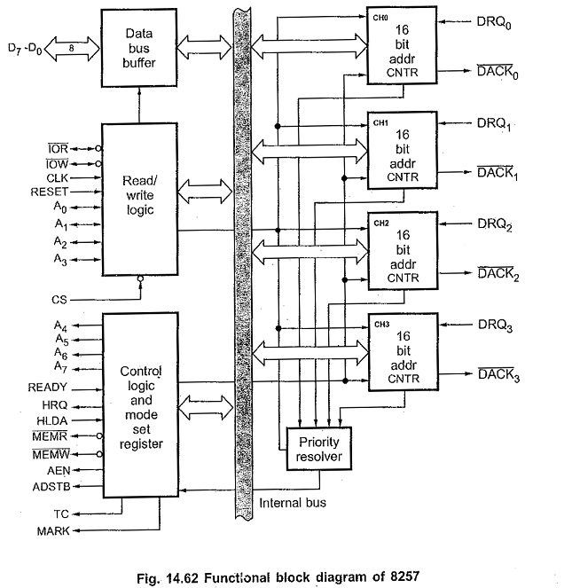

Data Bus Buffer:
It is a tri-state, bi-directional, eight bit buffer which interfaces the 8257 to the system data bus. In the slave mode, it is used to transfer data between microprocessor and internal registers of 8257. In master mode, it is used to send higher byte address (A₈-A₁₅) on the data bus.

Read/Write logic:
When the CPU is programming or reading one of the internal registers of Pin Diagram of 8257 (i.e, when the 8257 is in the slave mode), the Read/Write logic accepts the I/O Read (IOR) or I/O Write (IOW) signal, decodes the the least significant four address bits (A₀ – A₃) and either writes the contents of the data bus into the addressed register (if IOW is low) or places the contents of the addressed register onto the data bus (if IOR is low).
During DMA cycles (i.e. when the 8257 is in the master mode) the Read/Write logic generates the I/O read and memory write (DMA write cycle ) or I/O write and memory read (DMA read cycle) signals which control the data transfer between peripheral and memory device.

Mode Set Register:
Fig. 14.65 gives the format of mode set register. Least significant four bits of mode set register, when set, enable each of the four DMA channels. Most significant four bits allow four different options for the Pin Diagram of 8257.
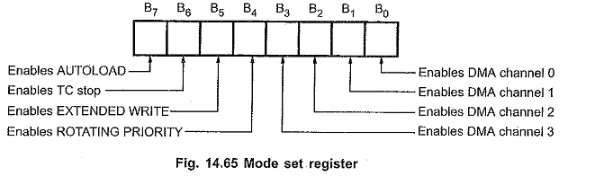

Status Register:
Fig. 14.66 shows the status register format. As said earlier, it indicates which channels have reached a terminal count condition and includes the update flag described previously.
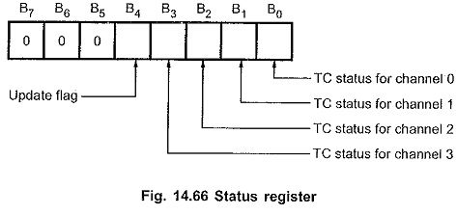
The TC status bit, if one, indicates terminal count has been reached for that channel. TC bit remains set until the status register is read or the 8257 is reset. The update flag, however, is not affected by a status read operation.
The update flag bit, if one, indicates CPU that 8257 is executing update cycle. In update cycle 8257 loads parameters in channel 3 to channel 2.

Priority Resolver:
It resolves the peripherals requests. It can be programmed to work in two modes, either in fixed mode or rotating priority mode.

Operating Modes of 8257:
The Operating Modes of 8257 can be programmed to operate in following modes :

Rotating Priority Mode :
In rotating priority mode, the priority of the channels has a circular sequence. In this, channel being serviced gets the lowest priority and the channel next to it gets the highest priority as shown in Fig. 14.67.
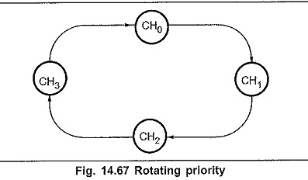
Thus, with rotating priority in a single chip DMA system, any device requesting service is guaranteed to be recognized after no more than Jhree higher priority services have occurred. This prevents any one channel from monopolizing the system. The rotating priority mode can be set by writing logic ‘1’ in the bit 4 of the mode set register.

Fixed Priority Mode :
In the fixed priority, channel 0 has the highest priority and channel 3 has the lowest priority. Table 14.5 shows the priority ratings.
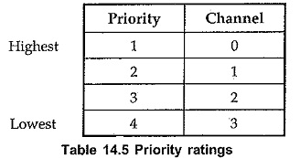

Extended Write Mode :
Microcomputer systems allow use of various types of memory and I/O devices with different access time. If a device can not be accessed within a specific amount of time it returns a “not ready” indication to the 8257 that causes the 8257 to insert one or more wait states in its internal sequencing. The extended write option provides alternative timing for the I/O and memory write signals which allows the devices to return an early READY and prevents the unnecessary occurrence of wait states in the Operating Modes of 8257. It does this by activating MEMW and IOW signals earlier in the DMA cycle, giving more setup time.

TC STOP Mode :
If the TC stop bit is set, a channel is disabled (i.e. its enable bit is reset) after the terminal count (TC) output goes high, thus automatically preventing further DMA operation on that channel. To enable DMA operation on the channel it is necessary to set enable bit of the corresponding channel in the mode set register. If the TC STOP bit is not set, the occurrence of the TC output has no effect on the channel enable bits.

Auto Load Mode :
Auto load Mode when enabled, permits block chaining operations, without immediate software intervention between blocks. In this mode, channel 2 parameters (DMA starting address, terminal count and DMA transfer mode) are initialized as usual for the first data block. These parameters are automatically duplicated in the channel 3 registers when channel 2 is initialized. After the first block of DMA cycles is executed by channel 2 (i.e., after the TC output goes high), the parameters stored in the channel 3 registers are transferred to channel 2 during an ‘update’ cycle and next block of DMA cycle is executed. This repeat block operations can be used in applications such as CRT refreshing.
During the update cycle, it is necessary to prevent the CPU from inadvertently skipping a data block by overwriting a starting address or terminal count in the channel 3 registers before those parameters are properly auto-loaded into channel 2.

