nanocrystal

WhatIs.com

A nanocrystal is a crystalline particle with at least one dimension measuring less than 1000 nanometers (nm), where 1 nm is defined as 1 thousand-millionth of a meter (10⁻⁹ m).
Nanocrystals have a wide variety of proven and potential applications. They have been used in the manufacture of filters that refine crude oil into diesel fuel. Nanocrystals can also be layered and applied to flexible substrates to produce solar panels. Research at the University of Queensland (Australia) have yielded promising results in this field. Titania nanocrystals can be suspended in liquid form and applied to surfaces, making it possible to literally paint a solar panel onto an exterior wall or roof.
Possible future uses of nanocrystals include:
- Production of hydrogen
- Removal of pollutants and toxins
- Medical imaging
- Bio-tags for gene identification
- Drug manufacture
- Protein analysis
- Flat-panel displays
- Illumination
- Optical and infrared lasers
- Optoisolators
- Magneto-optical memory chips
- Self-organized smart materials.

Properties of nanocrystals
The main reasons for the increased dissolution velocity and thus increased bioavailability are:

Increase of dissolution velocity by surface area enlargement
The size reduction leads to an increased surface area and thus according to the Noyes-Whitney equation (Noyes and Whitney 1897) to an increased dissolution velocity. Therefore micronization is a suitable way to successfully enhance the bioavailability of drugs where the dissolution velocity is the rate limiting step. By moving from micronization further down to nanonization, the particle surface is further increased and thus the dissolution velocity increases too. In most cases, a low dissolution velocity is correlated with low saturation solubility (Figure 1).

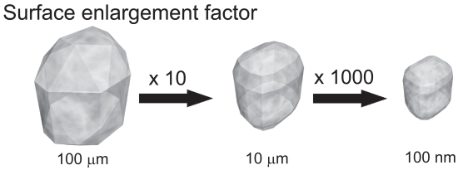
Figure 1
Surface enlargement and increase in number of crystals by particle size diminution.
Used with permission from Junghanns (2006).

Increase in saturation solubility
The general textbook statement is that the saturation solubility c_{s} is a constant depending on the compound, the dissolution medium and the temperature. This is valid for powders of daily life with a size in the micrometer range or above. However, below a critical size of 1–2 μm, the saturation solubility is also a function of the particle size. It increases with decreasing particle size below 1000 nm. Therefore, drug nanocrystals possess increased saturation solubility.

