**Acetone-Butanol Fermentation: Introduction, Chemical Structure, Process and Uses**

1. Introduction to the Process of Acetone-Butanol 2. Chemical Structure of Acetone and n Butanol 3. Fermentation Process 4. Uses.

**Introduction to the Process of Acetone-Butanol:**

Acetone and butanol are produced through anaerobic fermentation by species of Clostridium butyricum. The production of butanol by butyric acid bacteria was first observed by Louis Pasteur in the 19th century. Before World War-I processes involving microorganisms were developed for the production of butadiene which is required for the production of synthetic rubber. Later on Weizmann reported that Clostridium acetobutylicum is capable of producing acetone, butanol and ethanol in an economically feasible quantities.

During World War-I, acetone was in great demand to manufacture the explosive trinitrotoluene (TNT). Hence, the acetone-butanol fermentation rapidly expanded. But after war, the demand for acetone decreased and butanol increased, as it was required as a solvent for the rapid drying of nitrocellulose paints in automobile industry. Thus, the commercial process of acetone-butanol survived even after a lack of demand of acetone after World War-I.

But after World War II petroleum based processes replaced biological fermentation processes of acetone-butanol production, which lead to the closure of many industries. However, the fermentative production of acetone-butanol is still being carried out in certain countries where the carbon source material, specially, starchy material are available at cheaper rate. Vitamin B12is produced as a byproduct in this fermentation process. Biosynthesis of acetone-butanol is illustrated in Fig. 3.1.

**Chemical Structure of Acetone and n Butanol:**

**[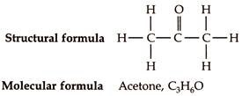](http://www.biotechnologynotes.com/wp-content/uploads/2018/06/clip_image002-6.jpg)**

**[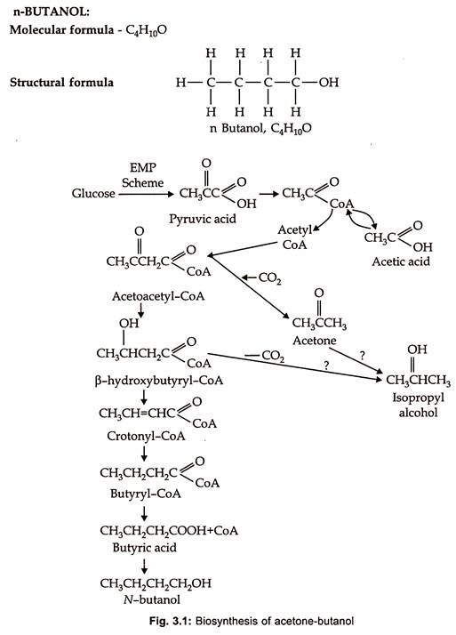](http://www.biotechnologynotes.com/wp-content/uploads/2018/06/clip_image004-4.jpg)**

**Fermentation Process of Acetone-Butanol:**

**Acetone-butanol fermentation process can be described under the following phases:**

(i) Production of inoculum

(ii) Preparation of medium

(iii) Fermentation process

(iv) Harvest and recovery

**(i) Production of Inoculum:**

Two species of Clostridium, which differ slightly in their nutritional requirements and fermentation factors, are generally employed for acetone-butanol fermentation (table 3.1).

**[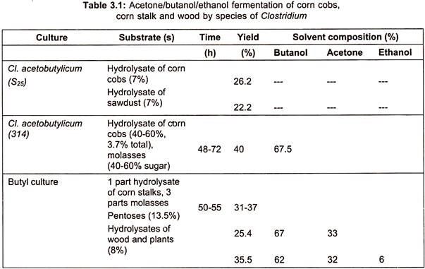](http://www.biotechnologynotes.com/wp-content/uploads/2018/06/clip_image006-5.jpg)**

Clostridium acetobutylicum and Cl. saccharo-acetobutylicum are the species involved. The fermentation by the former requires corn medium and the later molasses medium for the growth. In general, inoculum growth and fermentative production of the solvents are carried out at 31° to 32°C for Cl. saccharoacetobutylicum and at approximately 37°C for Cl. acetobutylicum.

**(a) Inoculum of Cl. Saccharoacetobutylicum:**

Inoculum of Cl. Saccharo acetobutylicum is developed employing molasses, calcium carbonate, ammonium sulphate or phosphate and sometimes corn-steep liquor. Clostridia, being spore formers, are easily maintained as soil stocks in contrast to the vegetative cells, the spores are not very sensitive to oxygen. However, prolonged storage of these spores leads to decrease in the acetone butanol production.

Spores from soil stocks are initially added to deep tubes of semisolid potato-glucose medium for molasses cultures. As the spores are added to the bottom of these tubes they along with soil particles sink to the bottom of the tubes and become submerged. The submerged location of the spores and high reducing power of the medium can protect the vegetative cells from oxygen after germination of spores/vegetative cells.

Inoculated tubes are heat shocked and rapidly cooled to incubation temperature to select heat resistant spores. The tubes are then incubated at 31° to 32°C for 20 hours. The growth that occurs in the tubes are used as inoculum for larger batch of molasses medium present in inoculum tanks. Further, increased volumes of inoculum are produced by successive transfers of approximately 2% to 4% inoculum by volume to larger media with incubation period of 20 to 24 hours at each transfer.

**At each of these stages of inoculum transfer, anaerobic conditions are produced by:**

1. The reducing condition of the medium,

2. Immediate use of freshly sterilized and cooled medium before air becomes incorporated,

3. Evolution of fermentation gasses

4. By filling the head space of the inoculum tank with sterile inert gas with a slight positive pressure.

**Various inoculum stages, particularly the last stage, before the inoculum is transferred to production tank, are checked for:**

1. pH,

2. Density of the inoculum,

3. Rate of gas evolution,

4. Presence of facultative anaerobe tested by aerobic plating on agar medium and

5. Microscopic observation for contamination by hanging drop method.

The inoculum of molasses medium is grown for 24 to 26 hours before addition to production tank.

**(b) Inoculum of Cl. Acetobutylicum:**

**Stages of inoculum preparation of this type of Clostridium are generally similar to the one described above for Cl. Saccharo-acetobutylicum except the following items:**

1. Spores of soil stock are added to the deep tubes containing corn medium with about 5% corn meal in water.

2. The tubes are incubated at 37°C for 20 hours.

3. The concentration of corn in the corn mash is adjusted to 6½ % during repeated inoculum transfers.

4. In addition, for all the tests described above, titratable acidity test is conducted for corn culture inoculum.

5. The final incubation of inoculum of corn culture is carried out until the titratable acidity test shows acid break up, that is, conversion of acetic acid to acetone and butyric acid to n-butanol.

**(ii) Preparation of Medium:**

**(a) Molasses Medium:**

It provides carbon source for Clostridium. Molasses which is formed as a by-product in the sugar industry, is used as a raw material for the preparation of the medium. Sugar content in the form of sucrose is maintained at 6%. For this either black strap or high-test molasses is used. Nitrogen source is added in the form of ammonium sulphate.

In addition calcium carbonate, superphosphate and sometimes corn-steep liquor are also added. Calcium carbonate is added to prevent development of gross acidity in the medium. Although, excess addition of this salt lowers the production of the solvents. Ammonium sulphate is added at 18 to 24 hours of fermentation.

**(b) Corn Medium:**

Corn meal is prepared by passing corn through a magnetic field to remove dust and metallic debris followed by degerming the corn. Corn oil is removed from the sprouted germ. The degermed corn is then ground to a fine powder in roller or hammer mill. To prepare corn-meal production medium 8% to 10% corn meal is added to water with or without stillage, that is, residue from the preceding fermentation. It is then heated for 20 minutes at 65°C to gelatinize the starch before sterilization of the medium.

The two media described above are then sterilized and employed in fermentation depending upon the type of Clostridium species used in the fermentation. Sometimes stillage, that is, residue formed in the previous fermentation is added to the medium approximately at 30% to 40%. It results in the addition of certain nutrients like proteins, carbohydrates and minerals to the freshly prepared medium.

**(iii) Fermentation Process:**

Fermentation is carried out under anaerobic conditions. Production tanks of the capacity of 50,000 to 2.5 lakhs gallons are used in the fermentation. The incubation period is 2 to 2 ½ days. If the freshly steamed molasses medium is employed, approximately 2 to 4% of inoculum is needed, while for freshly steamed corn medium slightly less inoculum is employed. The inoculum is added first to the production fermenter followed by the addition of medium.

This sequence facilitates thorough mixing of inoculum with the medium and maintain anaerobic condition. The yield of different solvents in different media are precised in Table 3.1. However, in an alternative procedure only a part of the medium is added to the inoculum and the inoculum is allowed to initiate growth before the rest of the medium is added.

**Fermentation generally passes through three phases:**

**(a) First Phase:**

In this phase rapid growth of the bacterium and formation of acetic acid and butyric acid in large amounts along with the production of large quantities of carbon dioxide and hydrogen gases. The pH of the medium which was initially 5.0 to 6.5 for corn medium and 5.5 to 6.5 for molasses medium, decreases and then remains constant for the rest of the fermentation process. This phase, lasts for approximately 13 to 17 hours of incubation. The titratable acidity increases to a maximum and adaptive enzymes are produced which convert acids to neutral solvents.

**(b) Second Phase:**

A sharp decrease in the titratable acidity due to conversion of more acids into acetone and butanol. This process is called as acid break, which gets delayed if there is contamination. The rate of gas formation reaches maximum after acid break. However, it gradually slows as the fermentation process proceeds further.

**(c) Third Phase:**

The rate of gas formation decreases substantially along with decreased rate of solvent production. The titratable acidity slowly increases leading to a pH of 4.2 to 4.4 in the corn medium and 5.2 to 6.2 in the molasses medium. Many cells undergo autolysis at this point resulting in the release of riboflavin into the medium.

**Yield:**

The ratio of yield of acetone, butanol and ethanol differ slightly depending on the fermentation medium. But, generally the yield is 2% by weight of the broth, which is approximately equal to 30% conversion of carbohydrate to solvents. In a corn medium the ratio of butanol, acetone and ethanol are 6:3:1 respectively, but in molasses medium the ratios are 6:5:3.

Apart from these solvents, 3 parts of carbon dioxide and 2 parts of hydrogen by volume are also produced as byproducts of the fermentation. They account for approximately half of the sugar medium. Total weight of the gases will be one and half times more than the solvents.

The acetone-butanol fermentation yields several products in addition to the gases described above. They include isopropanol, formic acid, acetic acid, butyric acid, acetylmethyl carbinol and yellow oil, which is a mixture of higher alcohols and acids, which are industrially very important. Contamination due to bacteriophages and Lactobacillus is a common problem which can be prevented by undertaking absolute sterilization.

**(iv) Harvest and Recovery:**

A beer still is used for the recovery of the products from the fermentation broth. The beer still is a tall vertical and continuous still consisting of about 30 perforated plates.

**The recovery process consists of the following steps:**

1. The fermentation broth is allowed to enter the still from top. It descends the still passing through perforated plates.

2. A continuous flow of steam is allowed into the still from its bottom. It moves up the still in a direction opposite to the direction of fermentation broth.

3. Acetone and butanol vaporizes due to the effect of steam.

4. The steam and solvents are then collected and condensed by cooling to get a solution which contains approximately 40% by weight of solvent mixture.

5. The individual solvents present in the solvent mixture are separated by fractional distillation.

6. Acetone and butanol are collected in separate fractions.

7. Ethanol and isopropanol are also collected as a single fraction and sold as a general solvent.

8. The residue contains riboflavin and other B vitamins as well as considerable quantity of bacterial cells. The residue is concentrated and dried and used as vitamin feed supplement. Flow diagram for the production of acetone butanol is shown in the Fig. 3.2.

**[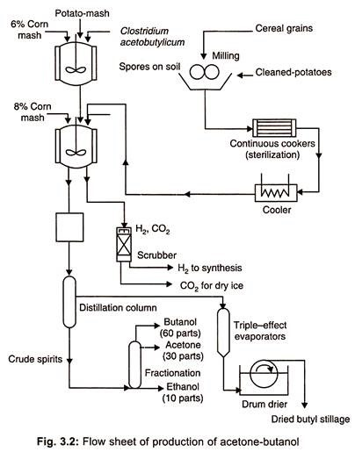](http://www.biotechnologynotes.com/wp-content/uploads/2018/06/clip_image008-4.jpg)**

**Uses of Acetone-Butanol:**

1. At present butanol is extensively used in brake fluid antibiotic recovery procedures, urea, formaldehyde resins, amines for gasoline additives and as ester in the protective coating industry.

2. Butanol is also used for the synthesis of butadiene which is used in the preparation of synthetic rubber.

3. Acetone is used as a universal organic solvent and also in the preparation of explosives like trinitrotoluene.

[**Home**](http://www.biotechnologynotes.com/) ›› [**Biotechnology**](http://www.biotechnologynotes.com/tag/biotechnology) ›› [**Industries**](http://www.biotechnologynotes.com/tag/industries) ›› [**Fermentation**](http://www.biotechnologynotes.com/tag/fermentation) ›› [**Acetone-Butanol Fermentation**](http://www.biotechnologynotes.com/tag/acetone-butanol-fermentation)

Releted Articles:

• **[Downstream Process in Fermentation [with methods] | Industries | Biotechnology](http://www.biotechnologynotes.com/industrial-biotechnology/fermentation-process/downstream-process-in-fermentation-with-methods-industries-biotechnology/13671" \o "Downstream Process in Fermentation [with methods] | Industries | Biotechnology)**

• **[Production Process of Ethyl Alcohol: Production and Applications |Anaerobic Fermentations](http://www.biotechnologynotes.com/industrial-biotechnology/anaerobic-fermentations/production-process-of-ethyl-alcohol-production-and-applications-anaerobic-fermentations/13723" \o "Production Process of Ethyl Alcohol: Production and Applications |Anaerobic Fermentations)**

• **[Lactic Acid: Structure, Biosynthesis, Fermentation Process and Uses in Food | Industries | Biotechnology](http://www.biotechnologynotes.com/industrial-biotechnology/lactic-acid/lactic-acid-structure-biosynthesis-fermentation-process-and-uses-in-food-industries-biotechnology/13758" \o "Lactic Acid: Structure, Biosynthesis, Fermentation Process and Uses in Food | Industries | Biotechnology)**

• [**Biosensors: Introduction, Categories, Applications, Advantages and Types| Devices | Industrial Biotechnology**](http://www.biotechnologynotes.com/industrial-biotechnology/biosensors/biosensors-introduction-categories-applications-advantages-and-types-devices-industrial-biotechnology/14019)