Heterolactic (Phosphoketolase) Pathway
- The phosphoketolase pathway is distinguished by the key cleavage enzyme, phosphoketolase, which cleaves pentose phosphate into glyceraldehyde-3-phosphate and acetyl phosphate.
- As a fermentation pathway, it is employed mainly by the heterolactic acid bacteria, which include some species of Lactobacillus and Leuconostoc.
- In hetero lactic fermentation, end product is ethanol and CO2 in addition to lactic acid.
- In this reaction glucose is first metabolized to pyruvate, acetic acid and CO2 by Pentose phosphate pathway.
- Pyruvate is then reduced to lactic acid whereas acetic acid is reduced to ethanol and CO2.
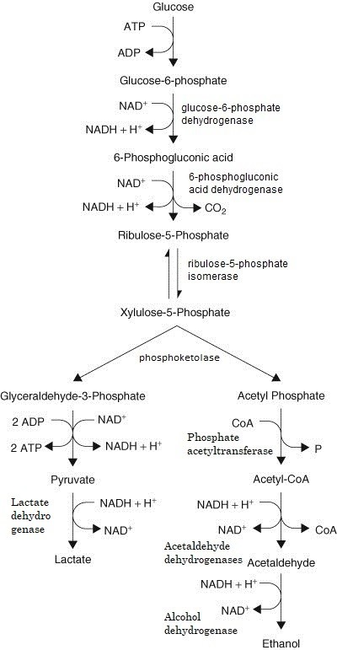

Steps:
- In this pathway, glucose-phosphate is oxidized to 6- phosphogluconic acid, which becomes oxidized and decarboxylated to form pentose phosphate.
- Unlike the Embden-Meyerhof pathway, NAD-mediated oxidations take place before the cleavage of the substrate being utilized.
- Pentose phosphate is subsequently cleaved to glyceraldehyde-3- phosphate (GAP) and acetyl phosphate.
- GAP is converted to lactic acid by the same enzymes as the EM pathway.
- This branch of the pathway contains oxidation coupled to a reduction while 2 ATP are produced by substrate-level phosphorylation.
- Acetyl phosphate is reduced in two steps to ethanol, which balances the two oxidations before the cleavage but does not yield ATP.
- The overall reaction is Glucose———->1 lactic acid + 1 ethanol +1 CO2 with a net gain of 1 ATP.
- The efficiency is about half that of the EM pathway.

Application:
- Heterolactic species of bacteria are occasionally used in the fermentation industry.
- For example, kefir, a type of fermented milk to yogurt, is produced by is produced using a heterolactic Lactobacillus species.
- Likewise, sauerkraut fermentations use Leuconostoc, a heterolactic bacterium, to complete the fermentation.
Heterolactic bacteria: Leuconostoc mesenteroides, Lactobacillus bifermentous, Leconostoc lactis

